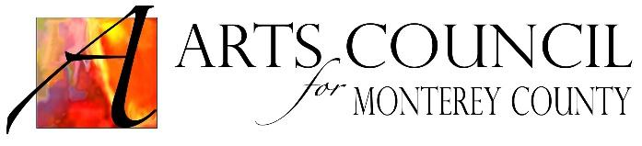

Arts Council for Monterey County
Marketing Team
Meeting Minutes

Date / Time: Tuesday, January 3, 2017 at 10:30 AM

Location: 528 College Dr., Salinas

Attendance: Ron Cacas (Chair), Susan Breen, Richard Anderson
Staff Present: Paulette Lynch, Berniz House, Tina Stewart

- Welcome & Message from the Chair

- Old Business: Review / Update the Following:

Review of Team purpose and goal: The purpose of the Marketing Team is to support the efforts of the Arts Council by engaging the correct audience, reach them with the most effective medium and cost in the most effective manner. This includes focusing all outreach on the question “What action we want to drive the audience to take.”

Team reviewed the budget vs. actual spending for the fiscal year. (Attached)
- The theater ads were split between the evergreen and gala budgets
- Adjustments will be made to the visitors guide and Champions budgets
- The team’s goal for the 2018 visitors’ guide ad is to have 8-10 arts and cultural groups partner in the ad.

Complimentary Tickets (6)
- 2 KSBW
- 2 Univison (Berniz will invite the GM)
- 2 Foolish Times
- 2 Men’s Warehouse
- 2 Macy’s
- 2 Monterey County Weekly

- New Business

Montereycounty365
- Our community has expressed the need for an arts calendar for Monterey County
- The smaller groups that need us the most have expressed the need for the calendar
- Berniz will have a report completed on the cost and benefits of the calendar by January 13th.

Writers
- The Marketing Team approved a $1500 sponsorship of Ernesto Altamirano for 6 months, expiring on June 30, 2017, as the Arts Council’s “man on the street” with the option to extend. He attends arts and cultural events and writes reviews on his webpage. The Arts Council has permission to use these reviews on our webpage. This serves several purposes, including engagement with the Spanish speaking community and getting press releases written. Ernesto is has performed research for several Spanish language channels and can serve as an expert on the market.
- Susan will speak to the writer of the Arts Council articles for the Foolish Times about the subject matter of his articles.
- Suggestions for articles: Importance and benefits of the arts on specific groups, teenagers, seniors, incarcerated youth, disabled, etc. The articles can also reference local arts and cultural events that can offer these benefits.
- Interview with the new Police Chief of the City of Salinas. Susan will speak to the writer of the Foolish Times articles to see if this is something realistic for him to do.
- Susan will get the editorial calendar for the Foolish Times and Ron will get it from the Monterey County Weekly.

___________________________________________________________________________
Next meeting: Monday, February 27, 2017 @1030AM at the 528 College Dr.
___________________________________________________________________________

